Ref1:

Ref2:

Ref3:

Ref4:

Ref5:

Ref6:

Ref7:

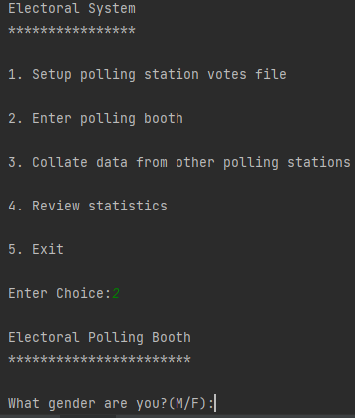

Ref8:

Ref9:

Ref10:

Ref11:

Ref12:

Ref13:

Ref14:

Ref15:

Ref16:

Ref17:



Ref18:



Ref19:

Ref20:

Ref21:

Ref22:

Ref23:

Ref24:

Ref25:

Ref26:

Ref27:

Ref28:

Ref29:

Ref30:

Ref31:

